Padua, March 9, 2022

AUTO E MOTO D’EPOCA PRESENTS ITSELF IN PARIS AND ESSEN.
ORGANIZATIONAL MACHINE IN FULL ACTIVITY FOR THE 2022 EDITION: FROM 20th TO 23rd OCTOBER AT THE PADUA EXHIBITION FAIR

AUTO E MOTO D'EPOCA website

The great organizational machinery of Auto E Moto d’Epoca is advancing, after the great success of the 2021 edition, the only major European fair in the classic car sector. And the tour also begins, which will see the Italian Fair protagonist at the main international events dedicated to the classic car which resume after the forced stops due to the Pandemic.
We start immediately with RÉTROMOBILE PARIS (March 16/20) and TECHNO CLASSICA ESSEN (March 23/27), two of the main international events dedicated to enthusiasts and collectors. Participation in prestigious exhibitions such as Paris and Essen allows not only to attract important dealers and enthusiasts to Italy but also to intercept the evolution of the market. Ready to present the 2022 new Edition, the organizers of the Vintage Cars Fair in Padova confirm their international vocation and ability to maintain an active participation in the sector all year round. For a show that has been able to update and renew itself year after year, to follow trends and expectations of an increasingly varied audience of enthusiasts (see Report 2021 Auto e Moto d'Epoca).

- Rétromobile Paris: Auto e Moto d’Epoca will be present in Hall 7.2 Stand H041. The 1947 FIAT 1100 S Sport Stanguellini will be exhibited (thanks to Promotor Classic).
- Techno Classica Essen: Auto e Moto d’Epoca will be present in Hall 6 Stand 6-384. The 1966 Maserati Mistral Spider and the 1934 Bianchi 500 Super Sport motorcycle will be exhibited (thanks to Ruote da Sogno).

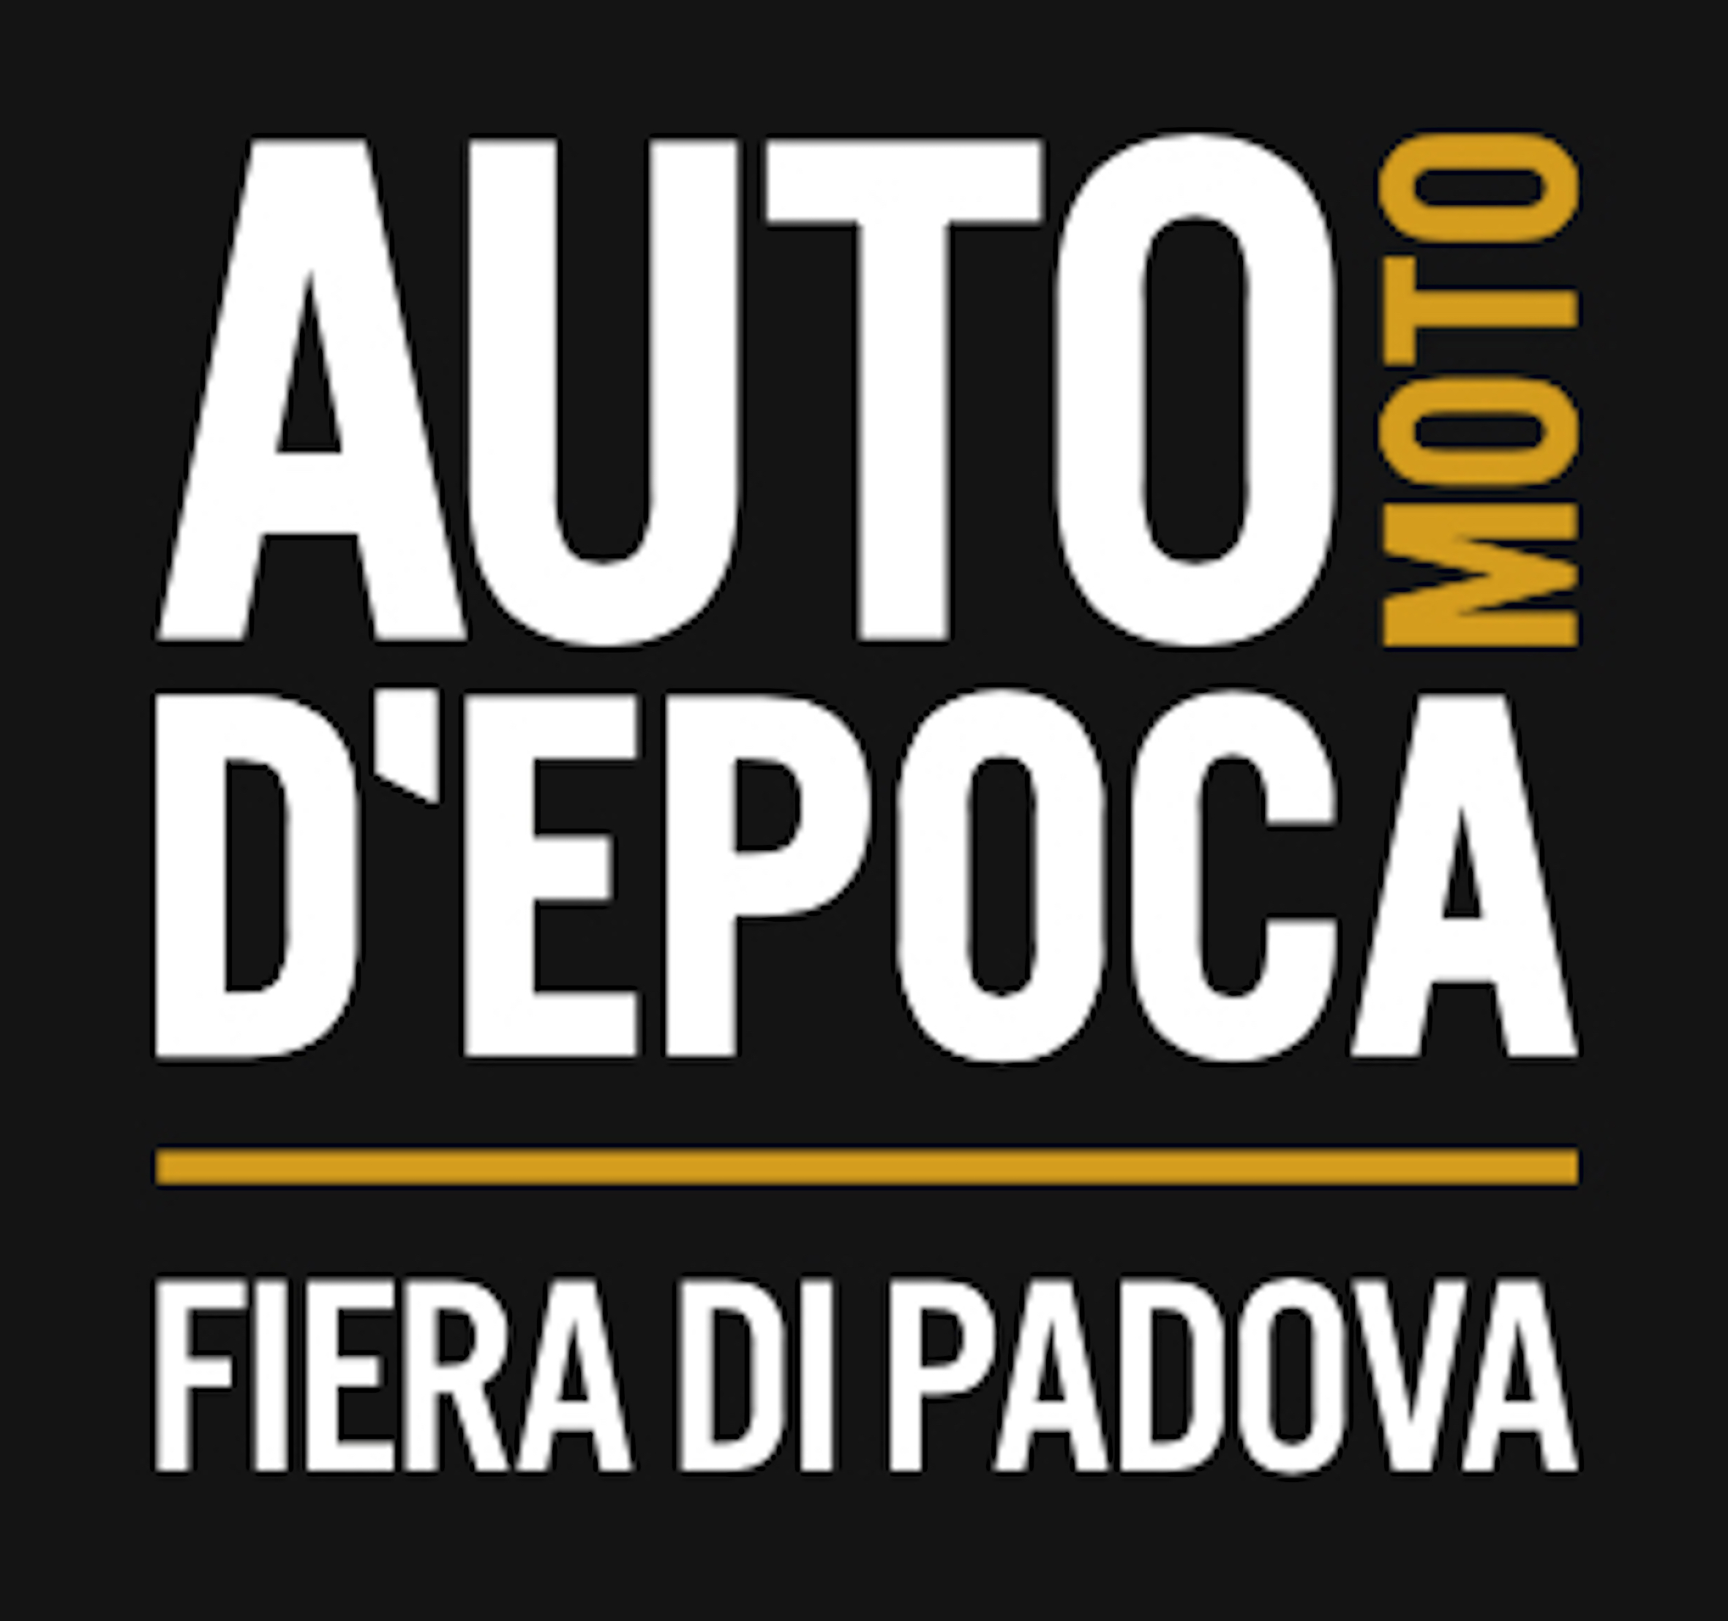
Press Office | Auto e Moto d’Epoca
Barbara Papuzzi | Sec & Associati |M +39 333 6535410 | papuzzi@seceassociati.it
Tommaso Vesentini | Intermeeting |M +39 3283615617 | vesentini@intermeeting.net
ORGANIZATIONAL STAFF: m +39 338 327 6262 marini@intermeeting.net

